Exercise 1: Control Structures

SET SERVEROUTPUT ON;

BEGIN

CREATE TABLE Customers (
CustomerID NUMBER PRIMARY KEY,
Name VARCHAR2(100),
DOB DATE,
Balance NUMBER,
LastModified DATE,
IsVIP VARCHAR2(5) DEFAULT 'FALSE'
);

CREATE TABLE Accounts (
AccountID NUMBER PRIMARY KEY,
CustomerID NUMBER,
AccountType VARCHAR2(20),
Balance NUMBER,
LastModified DATE,
FOREIGN KEY (CustomerID) REFERENCES Customers(CustomerID)
);

CREATE TABLE Transactions (
TransactionID NUMBER PRIMARY KEY,
AccountID NUMBER,
TransactionDate DATE,
Amount NUMBER,
TransactionType VARCHAR2(10),
FOREIGN KEY (AccountID) REFERENCES Accounts(AccountID)
);

CREATE TABLE Loans (
LoanID NUMBER PRIMARY KEY,
CustomerID NUMBER,
LoanAmount NUMBER,
InterestRate NUMBER,
StartDate DATE,
EndDate DATE,
FOREIGN KEY (CustomerID) REFERENCES Customers(CustomerID)
);

CREATE TABLE Employees (
EmployeeID NUMBER PRIMARY KEY,
Name VARCHAR2(100),
Position VARCHAR2(50),
Salary NUMBER,
Department VARCHAR2(50),
HireDate DATE
);

INSERT INTO Customers VALUES (1, 'John Doe', TO_DATE('1950-05-15', 'YYYY-MM-DD'), 9000, SYSDATE, 'FALSE');
INSERT INTO Customers VALUES (2, 'Jane Smith', TO_DATE('1980-07-20', 'YYYY-MM-DD'), 15000, SYSDATE, 'FALSE');
INSERT INTO Accounts VALUES (1, 1, 'Savings', 9000, SYSDATE);
INSERT INTO Accounts VALUES (2, 2, 'Checking', 15000, SYSDATE);
INSERT INTO Transactions VALUES (1, 1, SYSDATE, 200, 'Deposit');
INSERT INTO Transactions VALUES (2, 2, SYSDATE, 300, 'Withdrawal');

INSERT INTO Loans VALUES (1, 1, 5000, 5, SYSDATE, ADD_MONTHS(SYSDATE, 60));
INSERT INTO Loans VALUES (2, 2, 8000, 6, SYSDATE, SYSDATE + 10);
INSERT INTO Employees VALUES (1, 'Alice Johnson', 'Manager', 70000, 'HR', TO_DATE('2015-06-15', 'YYYY-MM-DD'));
INSERT INTO Employees VALUES (2, 'Bob Brown', 'Developer', 60000, 'IT', TO_DATE('2017-03-20', 'YYYY-MM-DD'));

BEGIN
FOR rec IN (
SELECT c.CustomerID, c.DOB, l.LoanID
FROM Customers c
JOIN Loans l ON c.CustomerID = l.CustomerID
) LOOP
IF MONTHS_BETWEEN(SYSDATE, rec.DOB)/12 > 60 THEN
UPDATE Loans
SET InterestRate = InterestRate - 1
WHERE LoanID = rec.LoanID;
END IF;
END LOOP;

DBMS_OUTPUT.PUT_LINE('--- Updated Loan Interest Rates ---');
FOR r IN (SELECT LoanID, InterestRate FROM Loans) LOOP
DBMS_OUTPUT.PUT_LINE('Loan ' || r.LoanID || ' -> Interest: ' || r.InterestRate || '%');
END LOOP;
END;
/

BEGIN
FOR rec IN (SELECT CustomerID, Balance FROM Customers) LOOP
IF rec.Balance > 10000 THEN
UPDATE Customers SET IsVIP = 'TRUE' WHERE CustomerID = rec.CustomerID;
END IF;
END LOOP;

DBMS_OUTPUT.PUT_LINE('--- VIP Status Updated ---');
FOR r IN (SELECT Name, IsVIP FROM Customers) LOOP
DBMS_OUTPUT.PUT_LINE('Customer: ' || r.Name || ' -> VIP: ' || r.IsVIP);
END LOOP;
END;
/

BEGIN
DBMS_OUTPUT.PUT_LINE('--- Loan Reminders (Due in 30 Days) ---');
FOR rec IN (
SELECT l.LoanID, l.EndDate, c.Name
FROM Loans l
JOIN Customers c ON l.CustomerID = c.CustomerID
WHERE l.EndDate <= SYSDATE + 30
) LOOP
DBMS_OUTPUT.PUT_LINE('Reminder: Loan ID ' || rec.LoanID || ' for ' || rec.Name ||
' is due on ' || TO_CHAR(rec.EndDate, 'DD-MON-YYYY'));
END LOOP;
END;
/

OUTPUT:
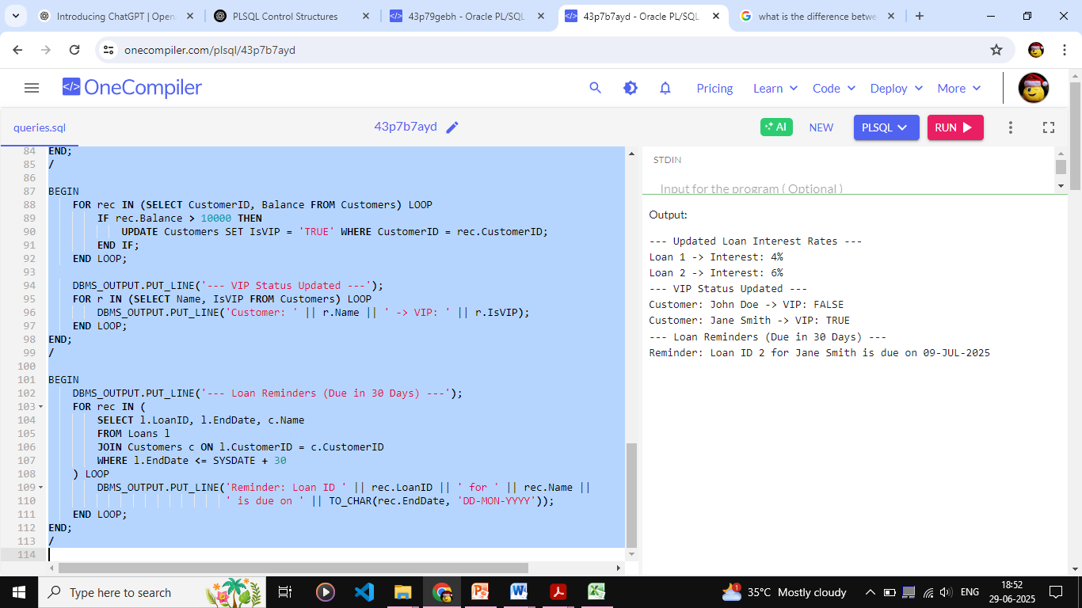
Exercise 3: Stored Procedures

SET SERVEROUTPUT ON;

CREATE TABLE Customers (
CustomerID NUMBER PRIMARY KEY,
Name VARCHAR2(100),
DOB DATE,
Balance NUMBER,
LastModified DATE,
IsVIP VARCHAR2(5) DEFAULT 'FALSE'
);
/

CREATE TABLE Accounts (
AccountID NUMBER PRIMARY KEY,
CustomerID NUMBER,
AccountType VARCHAR2(20),
Balance NUMBER,
LastModified DATE,
FOREIGN KEY (CustomerID) REFERENCES Customers(CustomerID)
);
/

CREATE TABLE Transactions (
TransactionID NUMBER PRIMARY KEY,
AccountID NUMBER,
TransactionDate DATE,
Amount NUMBER,
TransactionType VARCHAR2(10),
FOREIGN KEY (AccountID) REFERENCES Accounts(AccountID)
);
/

CREATE TABLE Loans (
LoanID NUMBER PRIMARY KEY,
CustomerID NUMBER,
LoanAmount NUMBER,
InterestRate NUMBER,
StartDate DATE,
EndDate DATE,
FOREIGN KEY (CustomerID) REFERENCES Customers(CustomerID)
);
/

CREATE TABLE Employees (
EmployeeID NUMBER PRIMARY KEY,
Name VARCHAR2(100),
Position VARCHAR2(50),
Salary NUMBER,
Department VARCHAR2(50),
HireDate DATE
);
/

INSERT INTO Customers VALUES (1, 'John Doe', TO_DATE('1960-05-15', 'YYYY-MM-DD'), 9000, SYSDATE, 'FALSE');
INSERT INTO Customers VALUES (2, 'Jane Smith', TO_DATE('1980-07-20', 'YYYY-MM-DD'), 15000, SYSDATE, 'FALSE');
/

INSERT INTO Accounts VALUES (1, 1, 'Savings', 9000, SYSDATE);
INSERT INTO Accounts VALUES (2, 2, 'Checking', 15000, SYSDATE);
/

INSERT INTO Transactions VALUES (1, 1, SYSDATE, 200, 'Deposit');
INSERT INTO Transactions VALUES (2, 2, SYSDATE, 300, 'Withdrawal');
/

INSERT INTO Loans VALUES (1, 1, 5000, 5, SYSDATE, ADD_MONTHS(SYSDATE, 60));
INSERT INTO Loans VALUES (2, 2, 8000, 6, SYSDATE, SYSDATE + 10);
/

INSERT INTO Employees VALUES (1, 'Alice Johnson', 'Manager', 70000, 'HR', TO_DATE('2015-06-15', 'YYYY-MM-DD'));
INSERT INTO Employees VALUES (2, 'Bob Brown', 'Developer', 60000, 'IT', TO_DATE('2017-03-20', 'YYYY-MM-DD'));
/

CREATE OR REPLACE PROCEDURE ProcessMonthlyInterest IS
BEGIN
FOR rec IN (
SELECT AccountID, Balance FROM Accounts WHERE AccountType = 'Savings'
) LOOP
UPDATE Accounts
SET Balance = rec.Balance + (rec.Balance * 0.01)
WHERE AccountID = rec.AccountID;

DBMS_OUTPUT.PUT_LINE('Interest applied to Account ID ' || rec.AccountID);
END LOOP;
END;
/

CREATE OR REPLACE PROCEDURE UpdateEmployeeBonus (
p_department IN VARCHAR2,
p_bonus_percent IN NUMBER
) IS
BEGIN
FOR rec IN (
SELECT EmployeeID, Salary FROM Employees WHERE Department = p_department
) LOOP
UPDATE Employees
SET Salary = rec.Salary + (rec.Salary * p_bonus_percent / 100)
WHERE EmployeeID = rec.EmployeeID;

DBMS_OUTPUT.PUT_LINE('Bonus added to Employee ID ' || rec.EmployeeID);
END LOOP;
END;
/

CREATE OR REPLACE PROCEDURE TransferFunds (
p_from_acc IN NUMBER,
p_to_acc IN NUMBER,
p_amount IN NUMBER
) IS
v_from_balance NUMBER;
BEGIN
SELECT Balance INTO v_from_balance
FROM Accounts
WHERE AccountID = p_from_acc;

IF v_from_balance < p_amount THEN
DBMS_OUTPUT.PUT_LINE('Insufficient balance in Account ' || p_from_acc);
RETURN;
END IF;

UPDATE Accounts
SET Balance = Balance - p_amount
WHERE AccountID = p_from_acc;

UPDATE Accounts
SET Balance = Balance + p_amount
WHERE AccountID = p_to_acc;

DBMS_OUTPUT.PUT_LINE('Transferred ' || p_amount || ' from Account ' || p_from_acc || ' to Account ' || p_to_acc);
EXCEPTION
WHEN NO_DATA_FOUND THEN
DBMS_OUTPUT.PUT_LINE('One of the account IDs does not exist.');
WHEN OTHERS THEN
DBMS_OUTPUT.PUT_LINE('Error: ' || SQLERRM);
END;
/

BEGIN
DBMS_OUTPUT.PUT_LINE('--- Processing Monthly Interest ---');
ProcessMonthlyInterest;
END;
/

BEGIN
DBMS_OUTPUT.PUT_LINE('--- Updating Employee Bonus ---');
UpdateEmployeeBonus('IT', 10);
END;
/

BEGIN
DBMS_OUTPUT.PUT_LINE('--- Transferring Funds ---');
TransferFunds(1, 2, 300);
END;
/

OUTPUT:
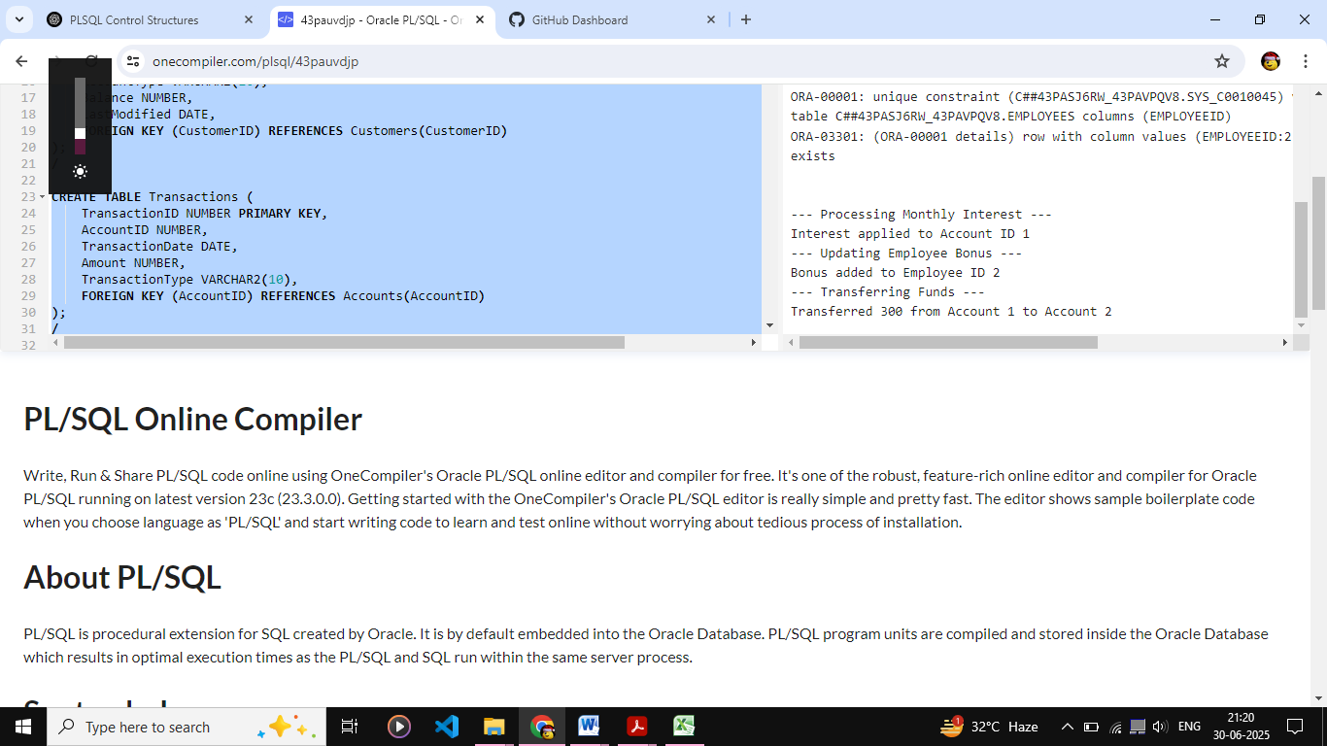

Exercise 1: Logging Error Messages and Warning Levels
LoggingExample.java
package com.example;
import org.slf4j.Logger;
import org.slf4j.LoggerFactory;
public class LoggingExample {
private static final Logger logger = LoggerFactory.getLogger(LoggingExample.class);
public static void main(String[] args) {
logger.error("This is an error message");
logger.warn("This is a warning message");
}
}

pom.xml
<project xmlns="http://maven.apache.org/POM/4.0.0"
xmlns:xsi="http://www.w3.org/2001/XMLSchema-instance"
xsi:schemaLocation="http://maven.apache.org/POM/4.0.0
http://maven.apache.org/xsd/maven-4.0.0.xsd">
<modelVersion>4.0.0</modelVersion>
<groupId>com.example</groupId>
<artifactId>logging-example</artifactId>
<version>1.0-SNAPSHOT</version>
<properties>
<maven.compiler.source>1.8</maven.compiler.source>
<maven.compiler.target>1.8</maven.compiler.target>
</properties>

<dependencies>
<dependency>
<groupId>org.slf4j</groupId>
<artifactId>slf4j-api</artifactId>
<version>1.7.30</version>
</dependency>
<dependency>
<groupId>ch.qos.logback</groupId>
<artifactId>logback-classic</artifactId>
<version>1.2.3</version>
</dependency>
</dependencies>
</project>

OUTPUT:
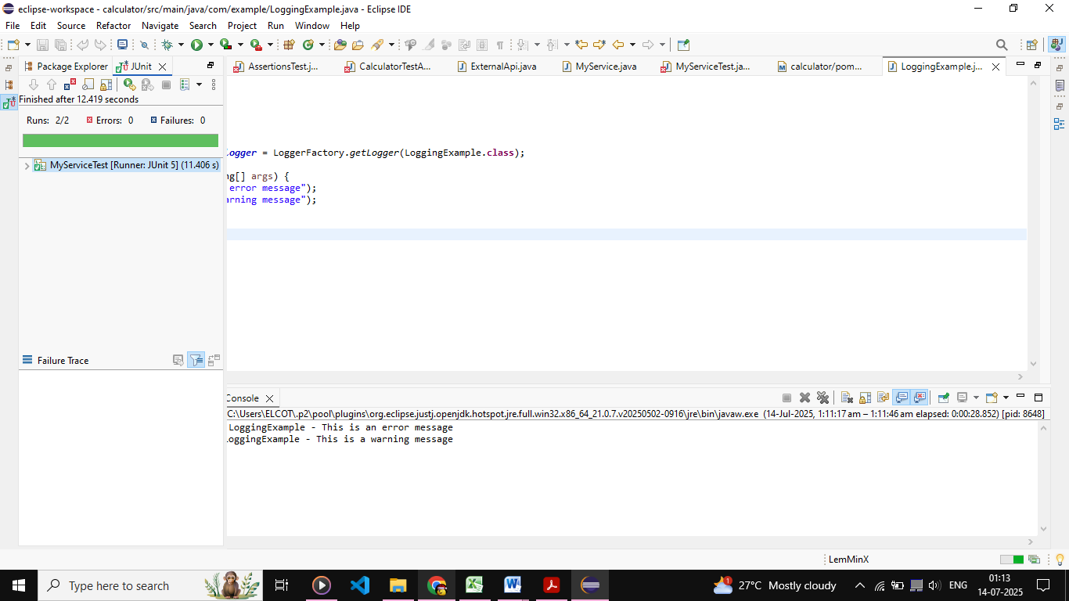

Exercise 1: Setting Up JUnit

Calculator.java
package com.example;
public class Calculator {
public int add(int a, int b) {
return a + b;
}
}

CalculatorTest.java
package com.example;
import org.junit.Test;
import static org.junit.Assert.*;
public class CalculatorTest {
@Test
public void testAdd() {
Calculator calc = new Calculator();
System.out.println("Test passed: 2 + 3 = " + calc.add(2, 3));
assertEquals(5, calc.add(2, 3));
}
}

pom.xml
<project xmlns="http://maven.apache.org/POM/4.0.0"
xmlns:xsi="http://www.w3.org/2001/XMLSchema-instance"
xsi:schemaLocation="http://maven.apache.org/POM/4.0.0
http://maven.apache.org/xsd/maven-4.0.0.xsd">
<modelVersion>4.0.0</modelVersion>
<groupId>com.example</groupId>
<artifactId>calculator</artifactId>
<version>1.0-SNAPSHOT</version>
<dependencies>
<dependency>
<groupId>junit</groupId>
<artifactId>junit</artifactId>
<version>4.13.2</version>
<scope>test</scope>
</dependency>
</dependencies>
</project>

OUTPUT:
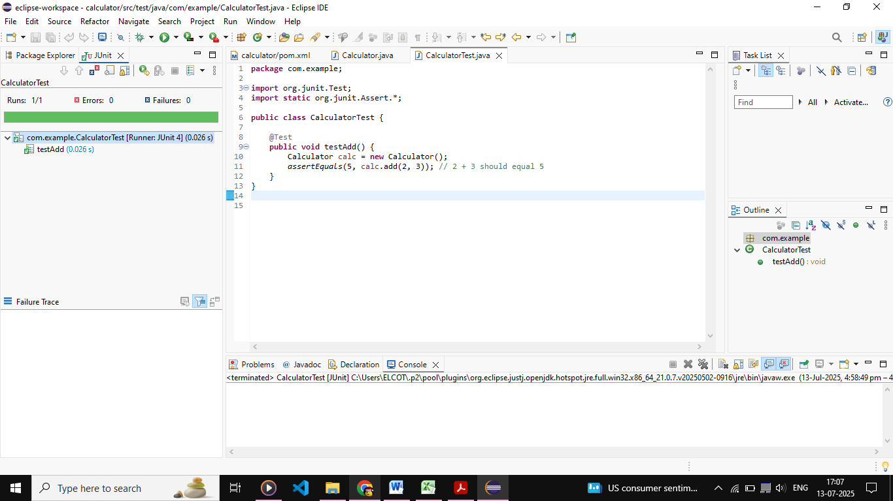

Exercise 3: Assertions in JUnit

AssertionsTest.java
package com.example;
import org.junit.Test;
import static org.junit.Assert.*;
public class AssertionsTest {
@Test
public void testAssertions() {
assertEquals(5, 2 + 3);
assertTrue(5 > 3);
assertFalse(5 < 3);
assertNull(null);
assertNotNull(new Object());
}
}

OUTPUT:
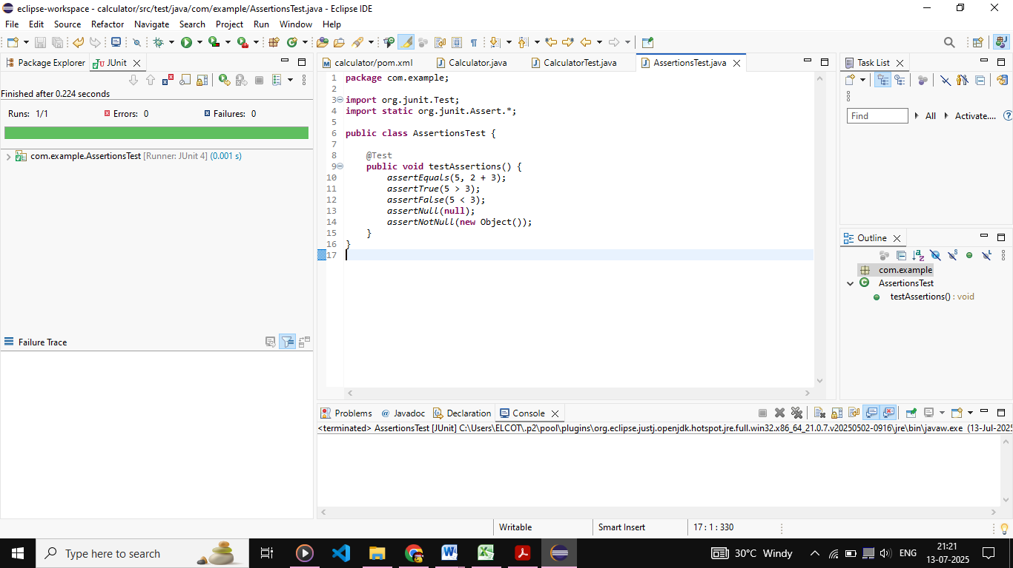
Exercise 4: Arrange-Act-Assert (AAA) Pattern, Test Fixtures, Setup and Teardown Methods in JUnit

Calculator.java
package com.example;
public class Calculator {
public int add(int a, int b) {
return a + b;
}
public int subtract(int a, int b) {
return a - b;
}
}

CalculatorTestAAA.java
package com.example;
import org.junit.After;
import org.junit.Before;
import org.junit.Test;
import static org.junit.Assert.*;
public class CalculatorTestAAA {
private Calculator calculator;
@Before
public void setUp() {
System.out.println("Setting up...");
calculator = new Calculator();
}
@After
public void tearDown() {
System.out.println("Cleaning up...");
calculator = null;
}
@Test
public void testAddition() {
int result = calculator.add(10, 5);
assertEquals(15, result);
}
@Test
public void testSubtraction() {
int result = calculator.subtract(10, 5);
assertEquals(5, result);
}
}

OUTPUT:
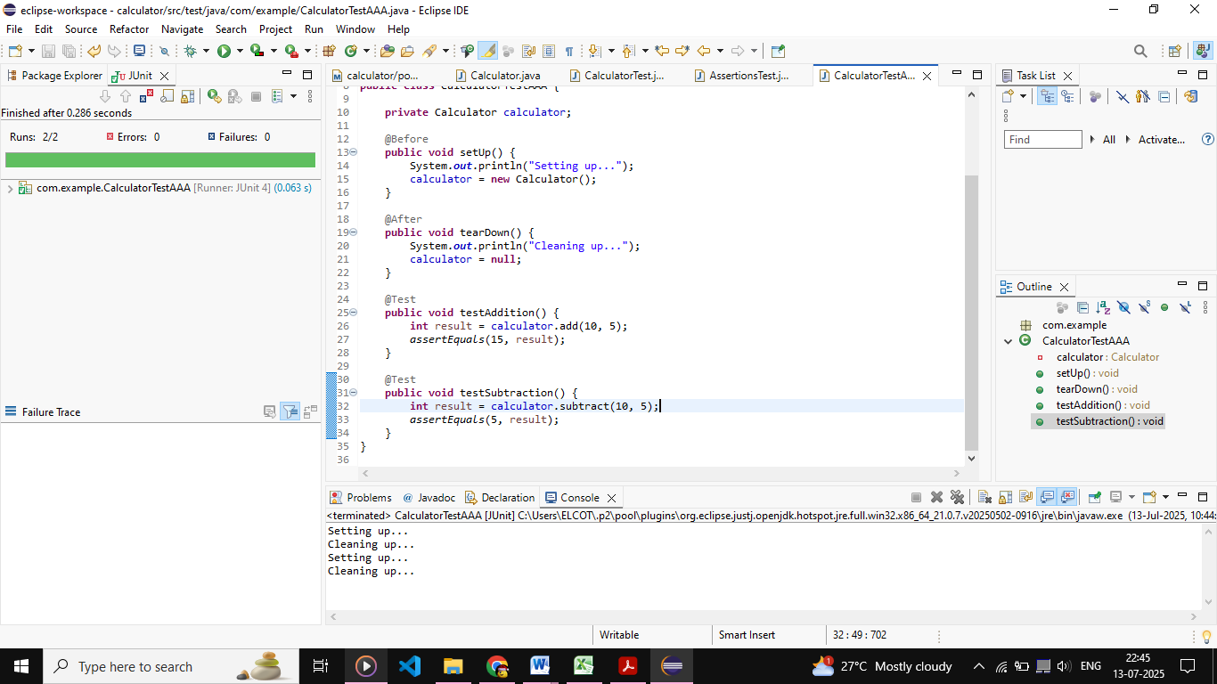

Exercise 1: Mocking and Stubbing

ExternalApi.java
package com.example;
public interface ExternalApi {
String getData();
}

MyService.java
package com.example;
public class MyService {
private ExternalApi api;
public MyService(ExternalApi api) {
this.api = api;
}
public String fetchData() {
return api.getData();
}
}

MyServiceTest.java
package com.example;
import org.junit.jupiter.api.Test;
import static org.junit.jupiter.api.Assertions.*;
import static org.mockito.Mockito.*;
public class MyServiceTest {
@Test
public void testExternalApi() {
ExternalApi mockApi = mock(ExternalApi.class);
when(mockApi.getData()).thenReturn("Mock Data");
MyService service = new MyService(mockApi);
String result = service.fetchData();
assertEquals("Mock Data", result);
}
}

OUTPUT:
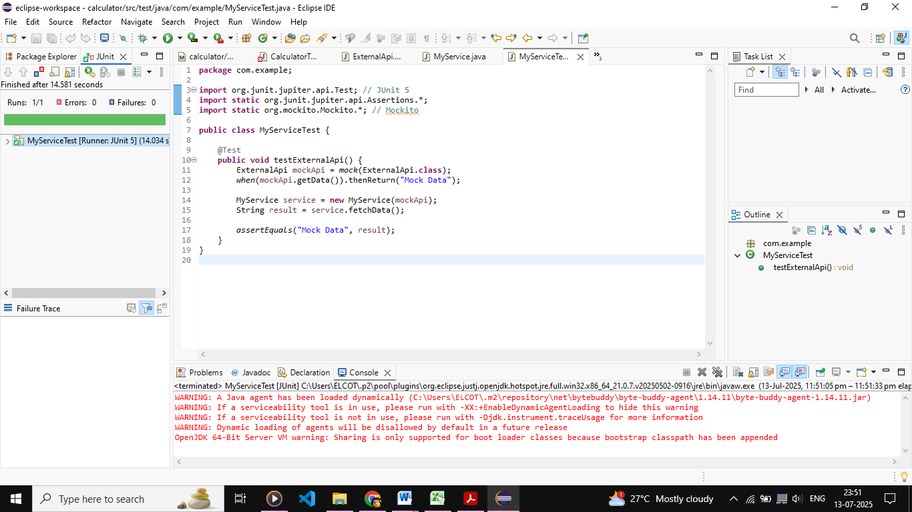

Exercise 2: Verifying Interactions

ExternalApi.java

package com.example;
public interface ExternalApi {
String getData();
}

MyService.java

package com.example;
public class MyService {
private ExternalApi api;
public MyService(ExternalApi api) {
this.api = api;
}
public String fetchData() {
return api.getData();
}
}

MyServiceTest.java

package com.example;
import org.junit.jupiter.api.Test;
import static org.mockito.Mockito.*;
import static org.junit.jupiter.api.Assertions.*;

public class MyServiceTest {

@Test

public void testExternalApi() {
ExternalApi mockApi = mock(ExternalApi.class);
when(mockApi.getData()).thenReturn("Mock Data");
MyService service = new MyService(mockApi);
String result = service.fetchData();
assertEquals("Mock Data", result);
}

@Test

public void testVerifyInteraction() {

ExternalApi mockApi = mock(ExternalApi.class);
MyService service = new MyService(mockApi);
service.fetchData();
verify(mockApi).getData();
}
}

OUTPUT:
